aQ | Computer Organization and Assembly Language (EL-2003)
Semester: Fall 2025
Section: BCS-3J / BCS-3K
Course Instructor: Ms. Seema Hashwani
LAB # 09

Integer Arithmetic

Lab Objectives:
By the end of this lab, students will be able to:
- Shift & rotate Instructions
- Multiplication and Division
- Extended Addition and Subtraction

Shift and Rotate Instructions

The 8086-based processors provide a complete set of instructions for shifting and rotating bits.
- Shift Instructions:
Shift instructions move bits a specified number of places to the right or left. The last in the direction of the shift goes into the carry flag, and the first bit is filled with 0 or with the previous value of the first bit.

SHL Instruction

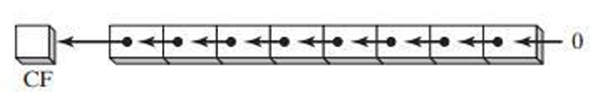
This instruction performs a logical left shift on the destination operand, filling the lowest bit with 0. The highest bit is moved to the Carry flag, and the bit that was in the Carry flag is discarded.
Syntax : SHL destination, count
The following lists the types of operands permitted by this instruction:
SHL reg, imm8
SHL mem, imm8
SHL reg, CL
SHL mem, CL
Example:
mov bl, 8Fh ; BL=10001111b
SHL bl, 1 ; CF=1, BL=00011110b
mov al, 10000000b ; AL=10000000b
SHL al, 2 ; CF=0, AL=00000000b

Bit Multiplication Example:
SHL can perform multiplication by powers of 2. Shifting any operand left by n bits multiplies the operand by 2 n .
For example, shifting the integer 5 left by 1 bit yields the product of 5 x 2¹ = 10
mov dl, 5 ;DL=00000101b =5
SHL dl, 1 ;CF=0, DL=00001010b =10

SHR Instruction

The SHR (shift right) instruction performs a logical right shift on the destination operand, replacing the highest bit with a 0. The lowest bit is copied into the Carry flag, and the bit that was previously in the Carry flag is lost.
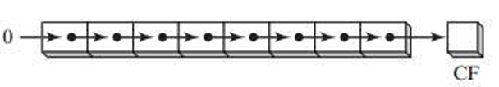

Examples:
mov al, 0D0h ; AL = 11010000b
shr al, 1 ; AL = 01101000b, CF = 0
mov al, 00000010b
shr al,2 ; AL = 00000000b, CF = 1
Bitwise Division:
Logically shifting an unsigned integer right by n bits divides the operand by 2^{n} . In the following statements, we divide 32 by 2¹, producing 16.
mov dl, 32 ;DL=00100000b =32
SHR dl, 1 ;DL=00010000b, CF=0 =16

SAL and SAR Instructions

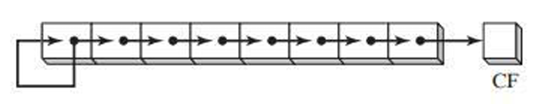
The SAL (shift arithmetic left) instruction works the same as the SHL instruction.
The SAR (shift arithmetic right) works like:

The following example shows how SAR duplicates the sign bit. AL is negative before and after it is shifted to the right:
mov al, 0F0h ; AL = 11110000b (-16)
sar al,1 ; AL = 11111000b (-8), CF = 0
Sign division:
mov dl, -128 ; DL = 10000000b
sar dl, 3 ; DL = 11110000b

Sign-Extend AX into EAX:
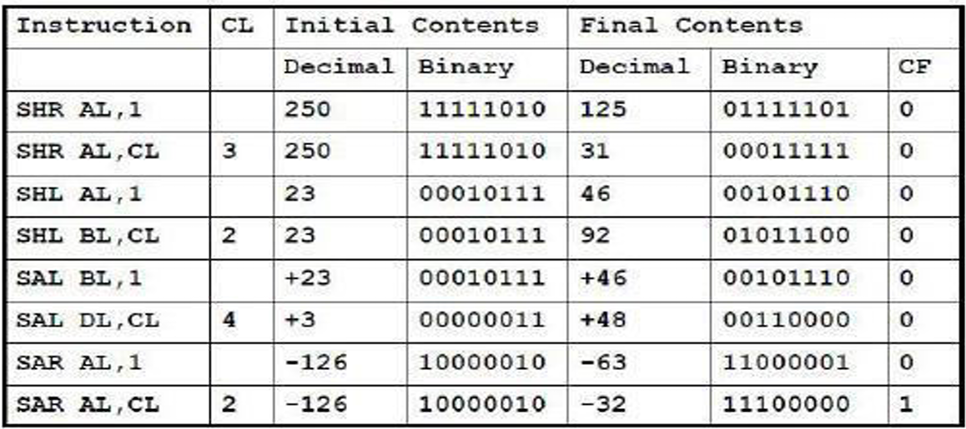
mov ax, -128 ; EAX = ????FF80h
shl eax, 16 ; EAX = FF800000h
sar eax, 16 ; EAX = FFFFFF80h

Rotate Instructions

Rotate instructions also move bits a specified number of places to the right or left. For each bit rotated the last bit in the direction of the rotate operation moves into the first bit position at the other end of the operand. With some variations, the carry bit is used as an additional bit of the operand. RCR (Rotate Carry Right) and RCL (Rotate Carry Left) instructions carry values from the first register to the second by passing the leftmost or rightmost bit through the carry flag.

ROL Instruction

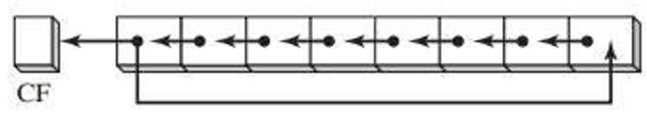
The ROL (rotate left) instruction shifts each bit to the left. The highest bit is copied into the Carry flag and the lowest bit position. The instruction format is the same as for SHL:

Example:
mov al, 40h ; AL = 01000000b
rol al, 1 ; AL = 10000000b, CF = 0
rol al, 1 ; AL = 00000001b, CF = 1
rol al,1 ; AL = 00000010b, CF = 0
Exchanging Groups of bits:
You can use ROL to exchange the upper (bits 4-7) and lower (bits 0-3) halves of a byte. For example, 26h rotated 4 bits in either direction becomes 62h.
mov al, 26h
rol al, 4 ; AL = 62h

ROR Instruction

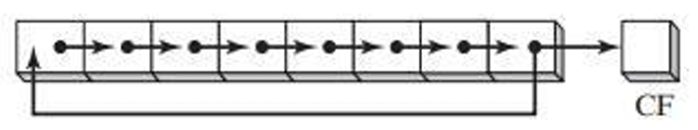
The ROR (rotate right) instruction shifts each bit to the right and copies the lowest bit into the Carry flag and the highest bit position.

Example:
mov al, 01h ; AL = 00000001b
ror al, 1 ; AL = 10000000b, CF = 1
ror al, 1 ; AL = 01000000b, CF = 0

RCL Instruction

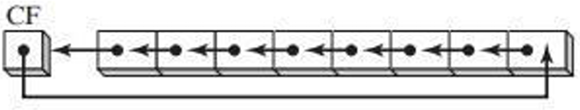
The RCL (rotate carry left) instruction shifts each bit to the left, copies the Carry flag to the LSB, and copies the MSB into the Carry flag:

Example:
clc ;CF=0
mov bl, 88h ; CF=0 , BL=10001000b
rcl bl, 1 ; CF=1 , BL= 00010000b

RCR Instruction

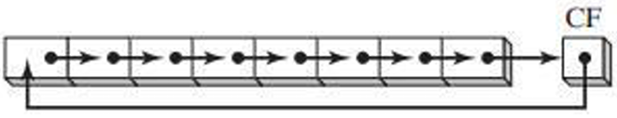
The RCR (rotate carry right) instruction shifts each bit to the right, copies the Carry flag into the MSB, and copies the LSB into the Carry flag

Example:
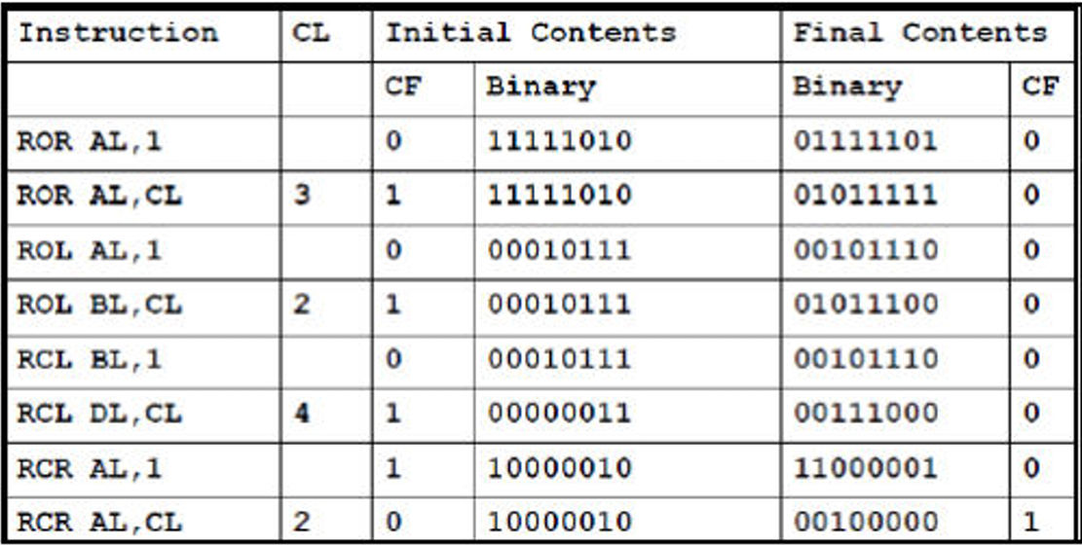
stc ;CF=1
mov ah, 10h ; AH = 00010000, CF = 1
rcr ah, 1 ; AH = 10001000, CF = 0

Applications

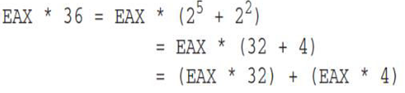
- Binary Multiplication

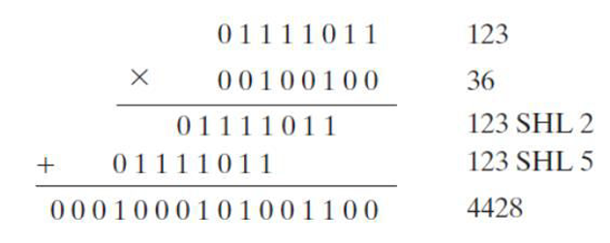
.code
mov eax, 123
mov ebx, eax
shl eax, 5 ; mult by 25
shl ebx, 2 ; mult by 22
add eax, ebx ; add the products
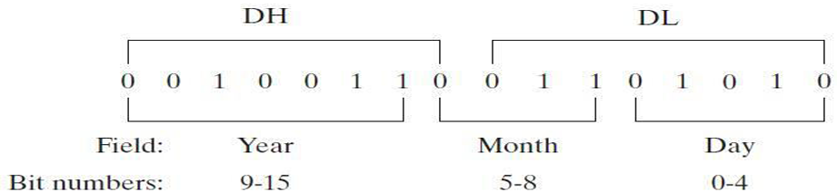
- Isolating Data Fields

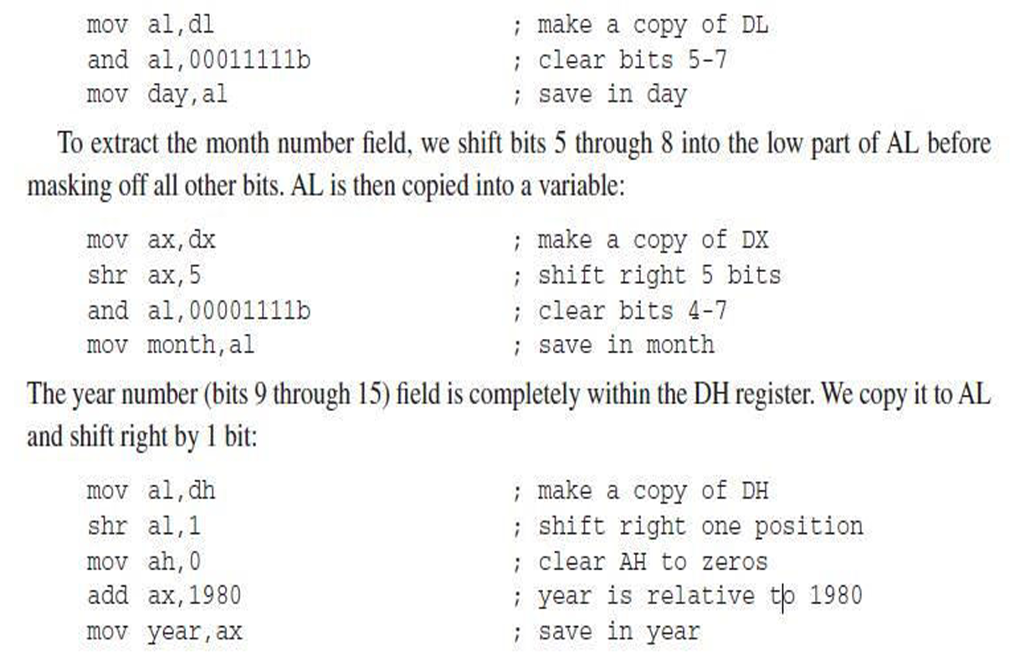
The following code example extracts the day number field of a date stamp integer by making a copy of DL and masking off bits not belonging to the field:


SHLD Instruction

The SHLD (shift left double) instruction shifts a destination operand a given number of bits to the left. The bit positions opened up by the shift are filled by the most significant bits of the source operand.
Format:
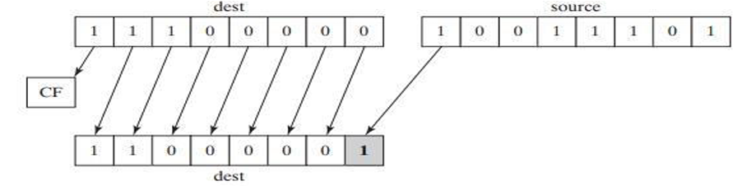
SHLD reg16, reg16, CL/imm8
SHLD mem16, reg16, CL/imm8
SHLD reg32, reg32, CL/imm8
SHLD mem32, reg32, CL/imm8
Example:
.data
a WORD 9BA6h
.code
mov ax, 0AC36h
shld a, ax, 4 ; a = BA6Ah

SHRD Instruction

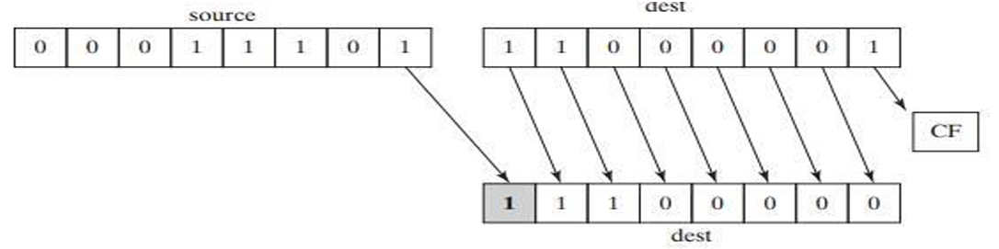
The SHRD (shift right double) instruction shifts a destination operand a given number of bits to the right. The bit positions opened by the shift are filled by the least significant bits of the source operand.

Example:
.code
mov ax, 234Bh
mov dx, 7654h
shrd ax, dx, 4 ;ax=4234h

MUL Instruction

The MUL instruction is for unsigned multiplication. Operands are treated as unsigned numbers. The three formats accept register and memory operands, but not immediate operands. The Carry flag is clear (CF = 0) because AH (the upper half of the product) equals zero.

Syntax:
MUL reg/mem8
MUL reg/mem16
MUL reg/mem32
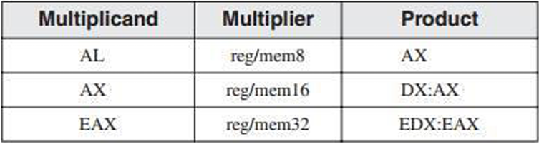
The table represents MUL operands:

EXAMPLE # 01:
INCLUDE Irvine32.inc
.code
main PROC
mov eax, 0
mov ebx, 0
mov al, 5h
mov bl,10h
mul bl ; AX = 0050h, CF = 0
call crlf
call dumpregs
exit
main ENDP
END main
EXAMPLE # 02:
.data
val1 WORD 2000h
val2 WORD 0100h
.code
mov ax, val1 ; AX = 2000h
mul val2 ; DX:AX = 00200000h, CF = 0
EXAMPLE # 03:
mov eax, 12345h
mov ebx,1000h ; EDX:EAX = 0000000012345000h, CF = 0
mul ebx

IMUL Instruction

The IMUL instruction is for signed multiplication. Operands are treated as signed numbers and result is positive or negative depending on the signs of the operands.
The x86 instruction set supports three formats for the IMUL instruction: one operand, two operands, and three operands.
- One-Operand Formats:
IMUL reg/mem8 ; AX = AL * reg/mem8
IMUL reg/mem16 ; DX:AX = AX * reg/mem16
IMUL reg/mem32 ; EDX:EAX = EAX * reg/mem32
- Two-Operand Formats:
IMUL reg16, reg/mem16
IMUL reg16, imm8
IMUL reg16, imm16
- Three-Operand Formats:
IMUL reg16, reg/mem16, imm8
IMUL reg16, reg/mem16, imm16
IMUL reg32, reg/mem32, imm8
IMUL reg32, reg/mem32, imm32
Example:
The following instructions multiply 48 by 4, producing +192 in AX. Although the product is correct, AH is not a sign extension of AL, so the Overflow flag is set:
mov al, 48
mov bl, 4
imul bl ;AX = 00C0h, OF = 1
The following instructions multiply -4 by 4, producing -16 in AX. AH is a sign extension of AL so the Overflow flag is clear:
.code
main PROC
mov eax, 0
mov ebx, 0
mov edx, 0
mov ax, -2
mov bx, 4 ; EDX:EAX = FFFFFFF8h, OF = 0
imul bx
call crlf
call dumpregs
The following instructions demonstrate two-operand formats:
Example :
INCLUDE Irvine32.inc
.data
word1 SWORD 4
dword1 SDWORD 4
.code
main PROC
mov eax, 0
mov ebx, 0
mov ax, -4 ; AX = -4
mov bx, 2 ; BX = 2
call dumpregs
imul bx, ax ;BX = -8
call dumpregs
imul bx, 2 ;BX= -16
call dumpregs
imul bx, word1 ;BX= -64
mov eax, -16
mov ebx, 2
call dumpregs
imul ebx, eax
call dumpregs
imul ebx, 2
call dumpregs
imul ebx, dword1
call dumpregs
exit
main ENDP
END main
The following instructions demonstrate three-operand formats:
Example:
INCLUDE Irvine32.inc
.data
word1 SWORD 4
dword1 SDWORD 4
.code
main PROC
mov ebx, 0
imul bx, word1, -2
call dumpregs
imul ebx ,dword1, -5
call dumpregs
exit
main ENDP
END main

DIV Instruction

The DIV (unsigned divide) instruction performs 8-bit, 16-bit, and 32-bit unsigned integer division. The single register or memory operand is the divisor. The formats are
DIV reg/mem8
DIV reg/mem16
DIV reg/mem32
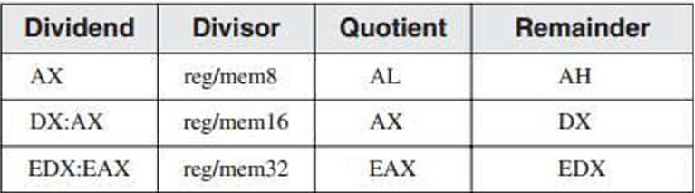
The following table shows the relationship between the dividend, divisor, quotient, and remainder:

Example:
mov ax, 0083h ; dividend
mov bl, 2 ; divisor
div bl ; AL = 41h, AH = 01h
mov dx, 0 ; clear dividend, high
mov ax, 8003h ; dividend, low
mov cx, 100h ; divisor
div cx ; AX = 0080h, DX = 0003h

Sign Extension Instructions(CBW,CWD,CDQ):

Dividends of signed integer division instructions must often be sign-extended before the division takes place. Intel provides three useful sign extension instructions: CBW, CWD, and CDQ.
The CBW instruction (convert byte to word) extends the sign bit of AL into AH, preserving the number’s sign. In the next example, 9Bh (in AL) and FF9Bh (in AX) both equal −101 decimal:
Example:
.data
byteVal SBYTE -101 ; 9Bh
.code
mov al, byteVal ; AL = 9Bh
cbw ; AX = FF9Bh
The CWD (convert word to doubleword) instruction extends the sign bit of AX into DX:
.data
wordVal SWORD -101 ; FF9Bh
.code
mov ax, wordVal ; AX = FF9Bh
cwd ; DX:AX = FFFFFF9Bh
The CDQ (convert doubleword to quadword) instruction extends the sign bit of EAX into EDX:
.data
.code
dwordVal SDWORD -101 ; FFFFFF9Bh
mov eax, dwordVal
cdq ; EDX:EAX = FFFFFFFFFFFFFF9Bh

IDIV Instruction

The IDIV (signed divide) instruction performs signed integer division, using the same operands as DIV.
Example:
The following instructions divide -48 by 5.
.data
byteVal SBYTE -48 ; D0 hexadecimal
.code
mov al, byteVal ; lower half of dividend
cbw ; extend AL into AH
mov bl, +5 ; divisor
idiv bl ; AL= -9, AH= -3

ADC Instruction

The ADC (add with carry) instruction adds both a source operand and the contents of the Carry flag to a destination operand.
Syntax:
ADC Destination, source
ADC reg, reg
ADC mem, reg
ADC reg, mem
ADC mem, imm
ADC reg, imm
Example # 01:
mov dl, 0
mov al, 0FFh
add al, 0FFh ; AL = FEh
adc dl, 0 ; DL/AL = 01FEh
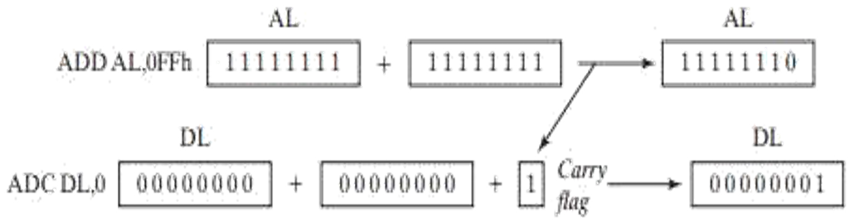

SBB Instruction

The SBB (subtract with borrow) instruction subtracts both a source operand and the value of the Carry flag from a destination operand.
Syntax: SBB Destination, source
Example:
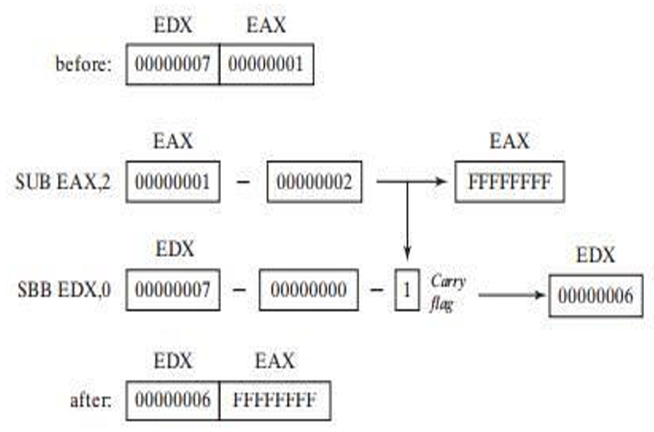
mov edx, 7 ; upper half
mov eax, 1 ; lower half
sub eax, 2 ; subtract 2
sbb edx, 0 ; subtract upper half

